Josiah Evans
jge842
EECS 351
Project C

Pyramid Noir

User Instructions: To move the camera forward, press the w button on the keyboard. To move the camera backward, press the s button on the keyboard. To move the camera left, press the a button on the keyboard. To move the camera right, press the d button on the keyboard. To turn the camera left, press the left arrow key on the keyboard. To turn the camera right, press the right arrow on the keyboard. To turn the camera up, press the up button on the keyboard. To turn the camera down, press the down arrow key on the keyboard.

To move the light source in the positive X direction, press the “+Lamp X” button under the canvas. To move the light source in the negative X direction, press the “-Lamp X” button under the canvas. To move the light source in the positive Y direction, press the “+Lamp Y” button under the canvas. To move the light source in the negative Y direction, press the “-Lamp Y” button under the canvas. To move the light source in the positive Z direction, press the “+Lamp Z” button under the canvas. To move the light source in the negative Z direction, press the “-Lamp Z” button under the canvas.

Goals: The primary goals of the Pyramid Noir project were threefold. To produce a space in which objects could be drawn independently of the camera position. To light objects in said space with a user adjustable light source and a light source affixed to the camera. To create objects to fill said space and provide interaction with the light sources.

Code Guide: The code for the camera is much the same as the code from the last project with regard to the camera. It uses a cylindrical encapsulator method to surround the camera position with an invisible cylinder from where coordinates for looking are drawn. However, one challenge was to affix a light source to the camera's position. By taking the camera's coordinates and updating the light position variables with the values, I was able to successfully affix the light source to the camera position.

To draw items in the space, I reused some of my code to build a pyramidal tower of arbitary height, size, scaling factors, and levels. However, I modified it to conform to the specifications of the enhanced light model.

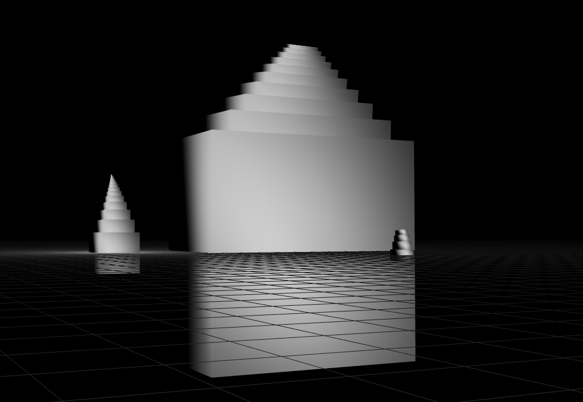
The light model is based off of the example sphere given to us, and is quite successful at adding multiple light sources. When combined, these light sources can generate truly amazing effects which mimic reality.

Figure 1. A scenic view of the pyramids from afar.

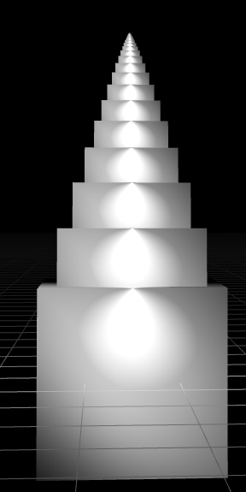
Figure 2. Advanced lighting effects combine

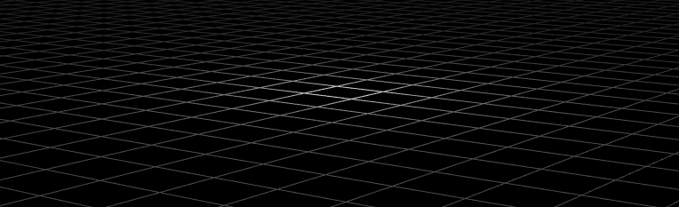

Figure 3. The light source moves to a new location

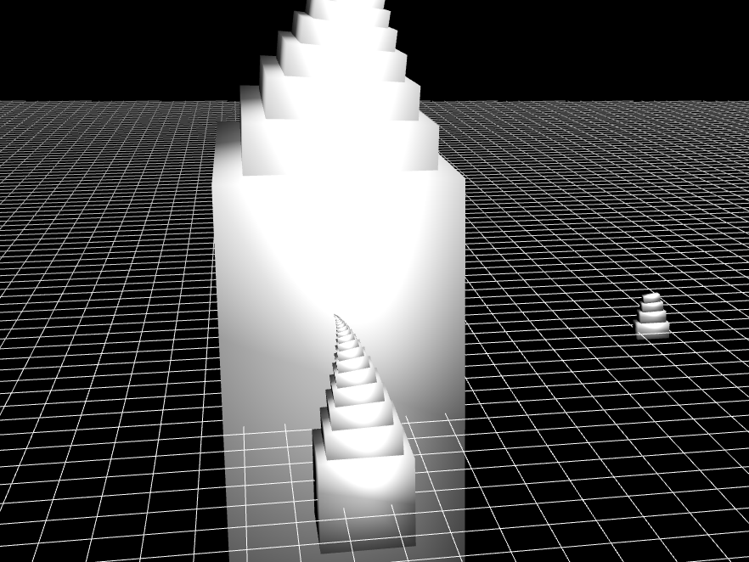

Figure 4. Moving the light source in the positive Y direction can have drastic effects

